Directions to Navy Operational Support Center San Antonio
Fort Sam Houston, TX

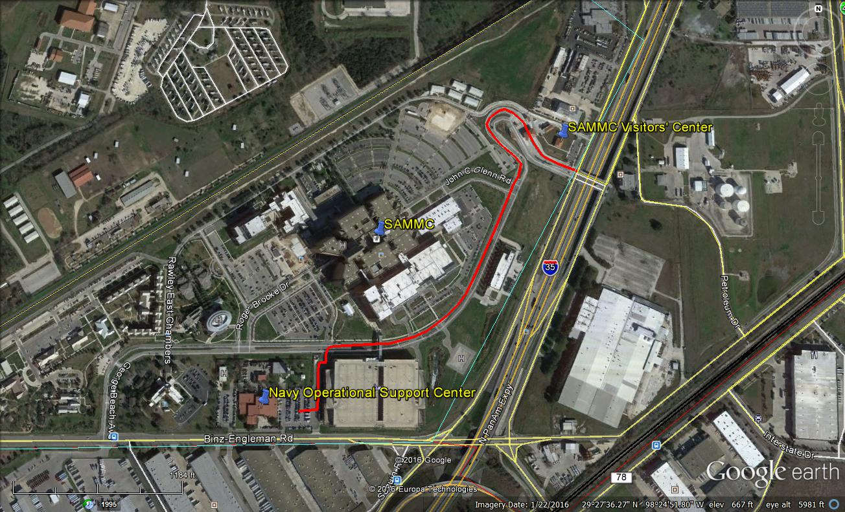

Directions:
From Interstate 35, take George Beach Ave exit. Go through Brooke Army Medical Center/San Antonio Military Medical Center main gate. Proceed along George Beach Avenue until you come to the traffic light next to a large parking garage on your left. Take a left at the light and proceed into the parking lot. The main entrance to the NOSC is on the south side of the building by the flagpole. You may park in either parking lot on the east or west sides of the building.

Entering Fort Sam Houston:
Fort Sam Houston is a federal military installation and all personnel entering it are subject to Department of Defense rules and regulations. If you do not have a DoD ID, you need to be added to our unit’s Base Access List two weeks PRIOR to coming on base. If you do not know if you are on our access list, please contact us at least two weeks in advance to make sure you’re on the list. Please do not bring any firearms or other weapons onto the installation even if you are licensed to carry a firearm. All vehicles and personnel are subject to search at all times while on the installation.

